Đề luyện thi vào lớp 6 môn Tiếng Anh, mức trung bình khá - Đề 4

TEST 4

Time allowed: 45 min.
I. Hãy chọn đáp án đúng A, B, C, hoặc D để hoàn thành những câu sau đây.
1. Brown is a worker ____ his son is a famous scientist.
A. so
B. but
C. or
D. because
2. Lan: My father is 38 years old.
Nam:_____ is your mother?
A. But how
B. Who
C. What
D. And how old
3. I’d like a sandwich and some cheese ____ my lunch.
A. at
B. on
C. for
D. during
4. I am planting some roses. ____ help me get some water?
A. Have you
B. Can you
C. Should you
D. Do you
5. Samuel:___ ?
Ted: On June 19th 1997.
A. When were you born?
B. What’s the date today?
C. What was the time?
D. When is your birthday?
II. Hãy chọn các từ/ cụm từ ở cột A đề ghép với cột B sao cho phù hợp. Thêm động từ để viết thành câu hoàn chỉnh.
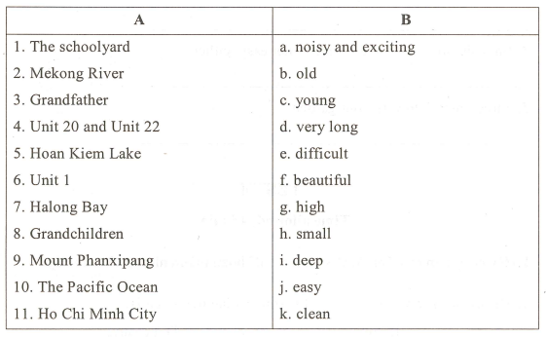
Ví dụ:
1. k: The schoolyard is clean.
2. _______________________________________________________.
3. _______________________________________________________.
4. _______________________________________________________.
5. _______________________________________________________.
6. _______________________________________________________.
7. _______________________________________________________.
8. _______________________________________________________.
9. _______________________________________________________.
10. _______________________________________________________.
11. _______________________________________________________.
III. Hãy điền dạng thích hợp của động từ trong ngoặc để hoàn thành những câu sau.
1. - “You (have) a brother or sister?” - “No, I don’t.”
_______________________________________________________.
2. My brother is lazy. Sometimes he (not do) his lessons before going to school.
_______________________________________________________.
3. You can’t go out now. It (rain) very hard.
_______________________________________________________.
4.- “You (know) that boy?”
- “Yes. He (be) a friend of my brother’s.”
_______________________________________________________.
IV. Hãy điền một từ vào mỗi chỗ trống để hoàn thành câu chuyện vui sau.
TWO APPLES
“Mother”, said a little boy, “May I have those two apples (1) _______the kitchen?”
“Yes, dear, if you want (2) _______."
“Thank you, mother, how nice that you (3) _______ yes”.
“Why, my son, (4)_____ you hungry?”
“Oh, no, but I ate thenrin (5) _______ morning”.
V. Hãy đọc đoạn văn sau và trả lời câu hỏi.
This is a picture of Mr. Smith’s family. Mr. Smith is a worker. He is 45 years old. This is his wife, Mrs. Linda Smith. She is from America. She is 42 but she looks very young. She is a nurse. Mary and David are their daughter and son. Mary is 20. She is a student. She is studying in France. David is four years younger than Mary, and he is a pupil. The Smiths live in a large flat in London.
1. How many people are there in the Smith family?
___________________________________________________
2. Where is Mrs. Linda Smith from?
___________________________________________________
3. Who are their children?
___________________________________________________
4. What is Mrs. Smith's job?
___________________________________________________
5. How old is David?
___________________________________________________

