Đề luyện thi vào lớp 6 môn Tiếng Anh, mức trung bình khá

ĐỀ 2

TEST 2

Time allowed: 45 min.
I. Hãy chọn đáp án đúng A, B, C, hoặc D để hoàn thành những câu sau đây.
1. What do your student often ________ after school ?
A. do
B. does
C. did
2. Our children ________ dinner at five thirty
A. has
B. have
C. are
3. Could you tell me ________ time, please ?
A. a
B. the
C. that
4. My brother ________ get up at six o'clock every morning
A. isn't
B. doesn't
C. don't
5. Would you like ________ more tea ?
A. any
B. have
C. some
II. Chọn các động từ cho sẵn và cho dạng đúng của các động từ đó sao cho phù hợp với các câu sau.
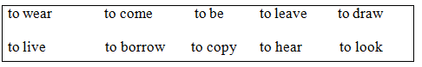
1. What time does the next bus _____, please?
2. She can’t___________ you, I’m afraid. She’s deaf.
3. I think Peter is going to be an artist. He _____ so well.
4. What colour _____ your new shoes?
5. Would you like to___________ to my party on Friday?
6. Can you___________ after the children tonight?
7. My brother___________ with a French family now.
8. They___________ many books from the library yesterday afternoon.
9. Shall I__________ my blue dress or red dress to the party?
10. Anna always _____ the way I dress
III. Em hãy chọn những từ, câu có sẵn để điền vào đoạn hội thoại.
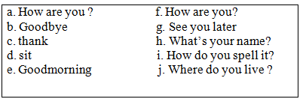
Nam : Good morning
Huong : (1) ________
Nam: Please (2) _______ down. My name is Nam. (3) _______ ?
Huong : My name is Nguyen Thanh Huong.
Nam : (4) _______ ?
Huong : H-U-O-N-G.
Nam : (5) _______, Huong ?
Huong : I'm fine, (6) _______ you ?
Nam : (7) _______ , Huong ?
Huong : I'm eleven years old.
Nam : (8) _______ ?
Huong : I live in Ha Noi city.
Nam : I live in Ho Chi Minh city. (9) _______
Huong : (10) _______ .
IV. Đặt câu hỏi cho các câu trả lời sau.
1. Mary got up at 8.30 last Sunday.
______________________________________.
2. She’s going to play tennis after school.
______________________________________.
3. James wants to be a doctor.
______________________________________.
4. It was sunny and windy in Ha Noi yesterday.
______________________________________.
5. The station? Go ahead, and then turn left at the traffíc lights. It is on the right.
______________________________________.

