ĐỀ TIẾNG ANH SỐ 05:
SEASONS
LOOK AND SAY
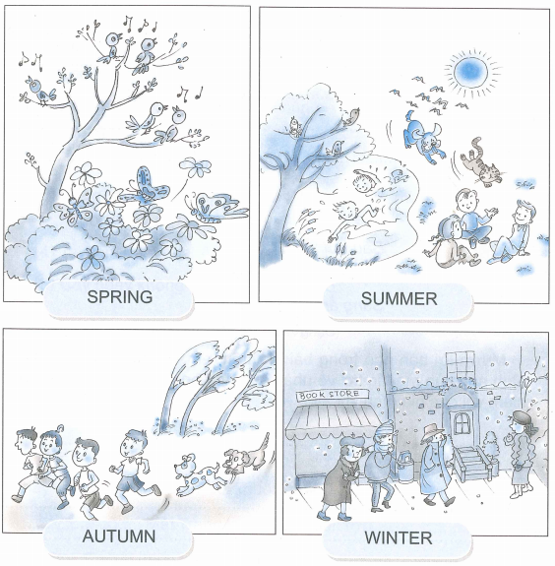
EXERCISE 1 : Pronunciation
1. Sentence stress
I ‘like ‘autum
‘School are not ‘open in ‘summer
A ‘new ‘shool year ‘start in ‘autum
2. Chant
It’s going to rain
I want a raincoat
It’s going to be sunny
I want an umbrella
It’s going to be cold
I want a warm coat
SPEACK AND WRITE
EXERCISE 2 : Description
Look at the pictures in Look and Say and describe them.
Suggestions:
It’s hot ...
There is ........
There are .........
How many ......... are there ?
Where are the .......... ?
What is/are ...... doing ?
EXERCISE 3 : Who does what and where
Look at the pictures in Look and Say and describe them, using the patterns above.
WHO | DOES WHAT | WHERE
The birds | are singing | in the tree

EXERCISE 4 : Story telling
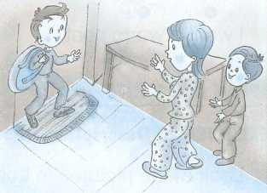
Bob is English. He stays with Quang's family.
"Welcome, Bob," says Quang's Mum.
I’m glad you are here."
"Me, too!" says Bob.
"Come on. Put your bag there."
says Quang’s Mum.

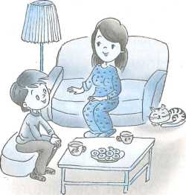
What's the weather like in summer, in England?" asks Quang's Mum.
"It's hot. But I like summer," says Bob.
"And in winter?" asks Quang's Mum.
"It's very cold," says Bob.
"Does it snow in winter?" asks Quang's Mum.
"Yes. But I like snow," says Bob.
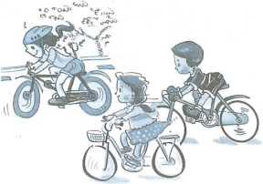
"Do you like to play games?" asks Quang.
"Yes. I like playing íootball. And you?" says Bob.
"I like playing tootball, and riding my bike."
"Yes. Let's go to the park."

Every evening, Bob eats dinner with Quang's family.
Bob doesn't eat much.
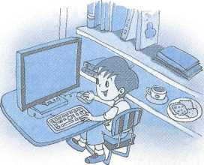
At night Bob sleeps in the guestroom.
Before bed, Bob always sends an e-mail to his family in England.
EXERCISE 5 : Read the story in EXERCISE 4 and answer Yes or No
 | YES | NO
1. Bob stays with Quang’s family.
2. Quang’s mother likes Bob.
3. Bob doesn’t like winter.
4. Bob plays volleyball
5. Quang likes riding his bike

EXERCISE 6 : Fill in the blank
living has together riding playing
good eats computer happy
Note : There are more than six words is the box
Bob is English. He is now (1) ............... with Quang's family. Every day they go to school (2) ................., and play football together. Bob likes (3) ................... a bike. But he is not (4) ................. at riding. Bob has lunch at school, but he (5) .................... with dinner Quang's family. Bob has a (6) ...................... He sends an e-mail to his family every evening. Bob is happy.

ĐÁP ÁN TIẾNG ANH.
EXERCISE 3 :
The birds | are spinging | in the tree
The boys and the girls | are playing | in the park
The boys and the dogs | are running | in the park
The men and the women | are walking | in the street
EXERCISE 5 : 1.Y ; 2.Y ; 3.Y ; 4.N ; 5.Y
EXERCISE 6 :
1 | 2 | 3 | 4 | 5 | 6
living | together | riding | good | eats | computer

