ĐỀ TIẾNG ANH SỐ 04:
FUTURE PLAN
LOOK AND SAY
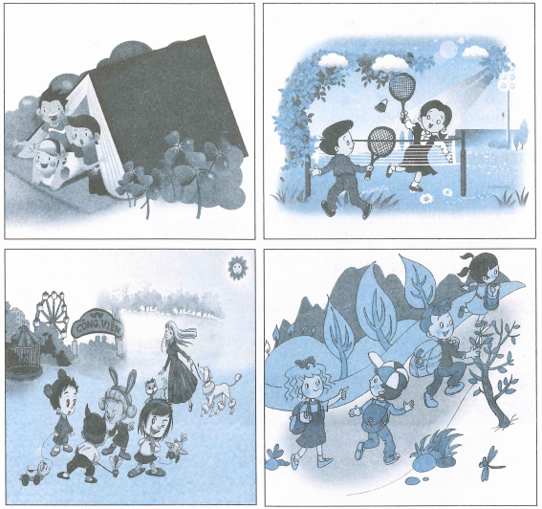
EXERCISE 1 : Pronunciation
1. Sentence stress
1. We are ‘going for a ‘picnic.
2. Thet are ‘going to ‘take a ‘walk.
3. I ‘like ‘playing in the ‘park
2. Chant
I’m going to buy sneackers
He’s going to buy sandals
She’s going to buy boots
Where are they?
They’re in the shoe shop
EXERCISE 2: Ask and answer
Look at the pictures in Look and Say, ask and answer
- Who is this/that?
- What is he going to do?
- Where is he going to do it?
EXERCISE 3 : Who does what and where
Look at the pictures in Look and Say and complete the following table.
WHO | WHAT...  GOING TO DO | WHERE
The boy and the girl | are going to play badminton | in the playground
EXERCISE 4 : Story telling
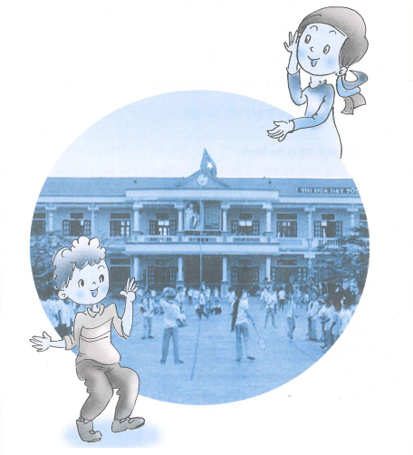
 | YES | NO
1. They are going to watch a badminton match
2. Many students are going to watch it
3. Ten students are going to play it
4. They are going to play in the playground
5. One team is going win
EXERCISE 6 : Fill in the blank
going running playground school wear
take blue win won wait come
Note : There are more than six worlds in the box
Elina and Mark are (1) to vvatch a badminton match. They are going to play in the (2) ................ at school. John's team is going to (3) ................. red, and Minh's team is going to wear (4) ................ Elina likes Minh's team ....................... and Mark likes John's team.
"Who is going to (5) ?" says Elina.
"(6) ................ and see," says Mark.

ĐÁP ÁN TIẾNG ANH
Exercise 3 :
The boy and the girl | are going to play badminton | in the playgorund
The boys | are sitting | in a tent
The girls | are playing | in the park
The boys and the girls | are going for a picnic | in the forest
Exercise 5 :
YES | NO
1, 2, 4, 5 | 3
Exercise 6 :
1 | 2 | 3 | 4 | 5 | 6
going | playgorund | wear | blue | win | wait

