TIẾNG ANH
A RICE-COOKING FESTIVAL
LOOK AND SAY
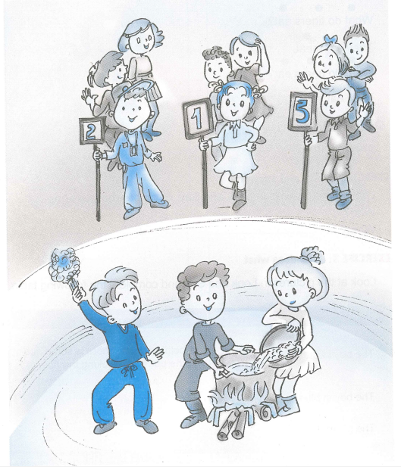
EXERCISE 1 : Pronunciation
1. Sentence stress
1. They are 'cooking 'rice.
2. We had a 'rice-cooking 'festival 'yesterday.
3. We 'got the 'First Prize
2. Chant
What do tigers eat?
They eat meat
What do bears eat?
They eat fish/
What do monkeys eat?
They eat fruit
EXERCISE 2: Ask and answer
Look at the pictures in Look and Say, describe what they do.
Who?
What?
EXERCISE 3: Who does what
Look at the pictures in Look and Say and complete the following table.
WHO | WHAT
They boy in brown | is holding a pot. There is come rice in the pot. He’s cooking the rice.
They boy in blue
They girl in white

READ AND WRITE
EXERCISE 4 : Story telling
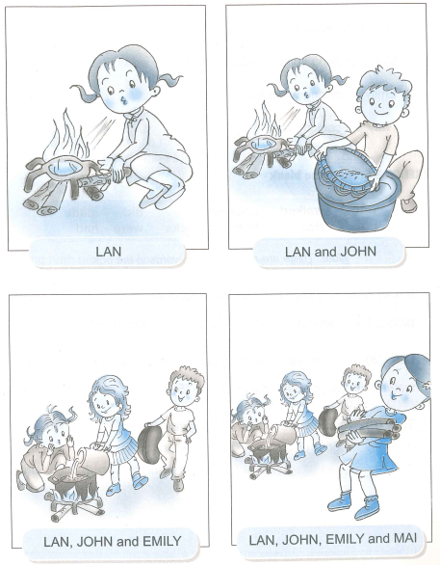
EXERCISE 5 : Read the story in Exercise 4 and answer Yes or No
 | YES | NO
1. Lan is making a fire
2. John is cooking rice
3. Mai is carrying some bamboo-sticks
4. Emily is pouring water into the pot
5. They are cooking rice
EXERCISE 6 : Fill in the blank
went | walk | cooked | did | made
got | rice | bamboo-sticks | were | had
Note : There are more than six worlds in the box
It was Sunday yesterday. Lan, Mai, John and Emily (1) .............. for a picnic. They didn’t buy foods. They (2) .............. their food
Lan (3) ............. a fire. John washed the rice. Emily (4) .............. some water to fill the pot. And Mai got some (5) ............. .
They (6) ........... a good dinner. They were happy.

ĐÁP ÁN TIẾNG ANH
EXERCISE 3 :
They in brown | is holding a pot. There is some rice in the pot.  He’s cooking the rice
The boy in blue | is holding a torch. He’s going to put it under the pot.
The girl in white | is pouring rice into the pot.
EXERCISE 5 :
YES | NO
1, 3, 4, 5 | 2
EXERCISE 6 :
1 | 2 | 3 | 4 | 5 | 6
went | cooked | made | got | bamboo-sticks | had

