ĐỀ TIẾNG ANH SỐ 2:
I LIKE FOOTBALL
LOOK AND SAY
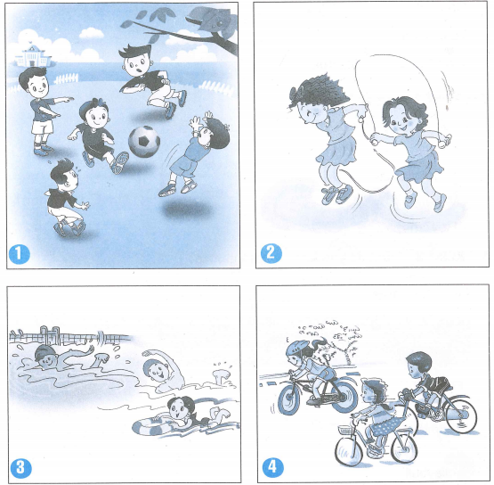
EXERCISE 1 : Pronunciation
1. Sentence stress
1. The ‘girl are ‘skipping in the ‘playground
2. I don’t ‘like ‘swimming
3. They are riding ‘up the ‘hill
2. Chant
Let’s play
Throw it
I threw it
Catch it
I caught it
Wow. That’s wonderful
EXERCISE 2 : Ask anh answer
Look at the pictures in Look and Say, ask and answer
- Who?
- What game?
- Where?
- How many?
EXERCISE 3 : What do you know about games?
Fill in the table
WHAT GAME | HOW MANY PLAYERS (A TEAM) | HOW MANY ROUNDS
Football | 11 | 2
Badminton
Volleyball
Basketball
Table tennis

READ AND WRITE
EXERCISE 4 : Story telling
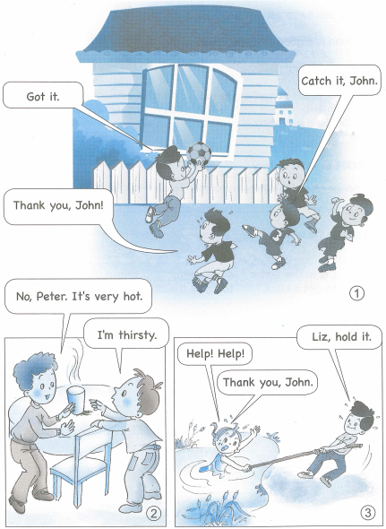
EXERCISE 5 : Read the story in Exercise 4 and answer Yes or No
 | YES | NO
1. Liz can swim very well
2. John is a good football player
3. Peter is thirsty
4. Peter wants something to eat
5. John is a good boy

EXERCISE 6 : Write a story
Choose one of the three pictures in Read and Write and write a story.
(Picture 3)
Liz is in the water...
Choose one of the three pictures in Read and Write and write a story.
(Picture 3)
Liz is in the water...
Liz in the water | can’t swim | shout
to point the stick to Liz | to get a stick | to see
....................................................................................................................................................................................................................................................................................................................................................................................................................................................................................................................................................................................................................................................................................................................................................................................................................................................................................................................................................................................................................
ĐÁP ÁN TIẾNG ANH
EXERCISE 3 :
Football | 11 | 2
Badminton | 2 | 3
Volleyball | 6 | 5
Basketball | 5 | 2
Table tennis | 1/2 | 3/5

EXERCISE 5 :
YES | NO
2, 3, 5 | 1, 4

EXERCISE 6 : Liz is in the water. She can’t swim
She shouts for help. John is walking along the pond. He sees her.
He goes to get a stick, and point it to her.
She holds it. John pulls her up.

