TIẾNG ANH
MY FATHER IS AN ENGINEER
LOOK AND SAY
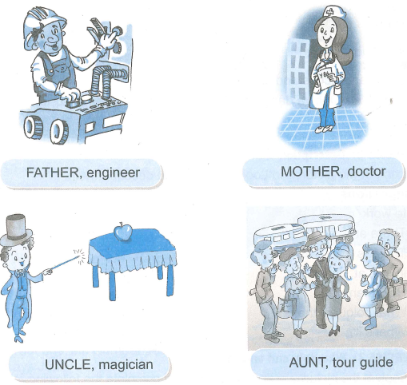
EXERCISE 1 : Pronunciation
1. Sentence stress
1. He's an engi'neer.
2. My 'father 'works in a 'factory.
3. They are 'out.
2. Chant
What does your mother like ?
She likes sandwiches.
What does your father like ?
He likes chicken.
What do you like ?
I like sandwiches anh chicken.
Chú thích : Đọc và đập nhịp vào âm tiết có _ ở dưới chân
SPEACK AND WRITE
EXERCISE 2 : Description
Look at the pictures in Look an Say and describe them.
Suggestions
to work
There are…..
There is……
in, on, at, under
How many….?
What colour is the….?
What’s it ?
EXERCISE 3 : Who, job, and where
Look at the pictures in Look in Say and complete the following table.

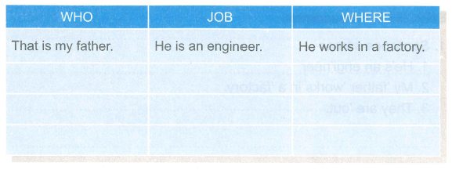
READ AND WRITE
EXERCISE 4 : Story telling
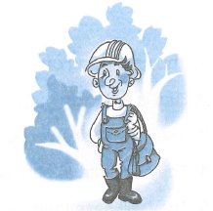
Look! That is Tim’s father. He is an engineer. He works in a factory. He staris his work at eight in the morning, and leaves at five in the afternoon. He is a good engineer.

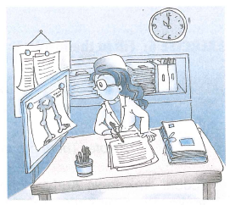
This is a children's hospital. That woman is a doctor. She's Tim's mother. She vvorks very hard. It is now 11 o'clock in the evening. She's working. She's on night duty today
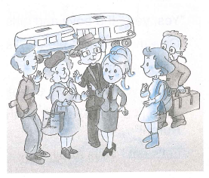
"What time do we start, Miss?" asks a tourist.
"In ten minutes," says Judi.
"Where is our car?" asks another tourist.
"That one, sir. Number 30B-6547," says Judi.
"What time do we arrive here?" asks another tourist.
"About 12 o'clock," says Judi.
"Where do we have lunch, Miss?" asks another tourist.
"At our hotel, Madam," answers Judi. Judi is always busy answering the questions.
EXERCISE 5 : Read the story in Exercise 4 and answer Yes or No
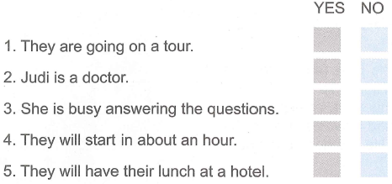
EXERCISE 6 : Fill in the blank
trick | play | around | picks | takes
shout | see | watch | cake | biscuits
Note : There are more than six words in the box.
"Look! I'm magic Andy. I can do a (1) " Andy is doing magic tricks. Boys and girls are sitting (2) …………… him. "Pick a card," says Andy. A girl (3)…..……. a card. "Is your card the eight of hearts?" says Andy. "Yes, it is."
"I can do one more trick," says Andy.
"Yes, yes," the boys and girls (4)
"Give me that box, please," says Andy.
"Here you are."
"Thank you. One, two, three! Look and (5) !" says Andy.
There is a big (6) in the box. The boys and girls shout happily,
"Hurah!"
"Let's eat," says Andy.

ĐÁP ÁN TIẾNG ANH
EXERCISE 3 :
That is my father  That is mother  That is my uncle  That is my aunt | He is an engineer  She’s a doctor  He’s a magician  She’s a tour guide | He works in a factory  She works in a hospital  He works at a theatre  She works for a touris company

EXERCISE 5 :
YES | NO
1, 3, 5 | 2, 4
EXERCISE 6 :
1 | 2 | 3 | 4 | 5 | 6
trick | around | takes | shout | see | cake

