………………… Primary School
Name:……………………………
Class: ……………………………
THE SECOND TERM TEST
Time allotted: 40 minutes
School year: 2017-2018

________________
A. Listening

Question 1: Listen and number


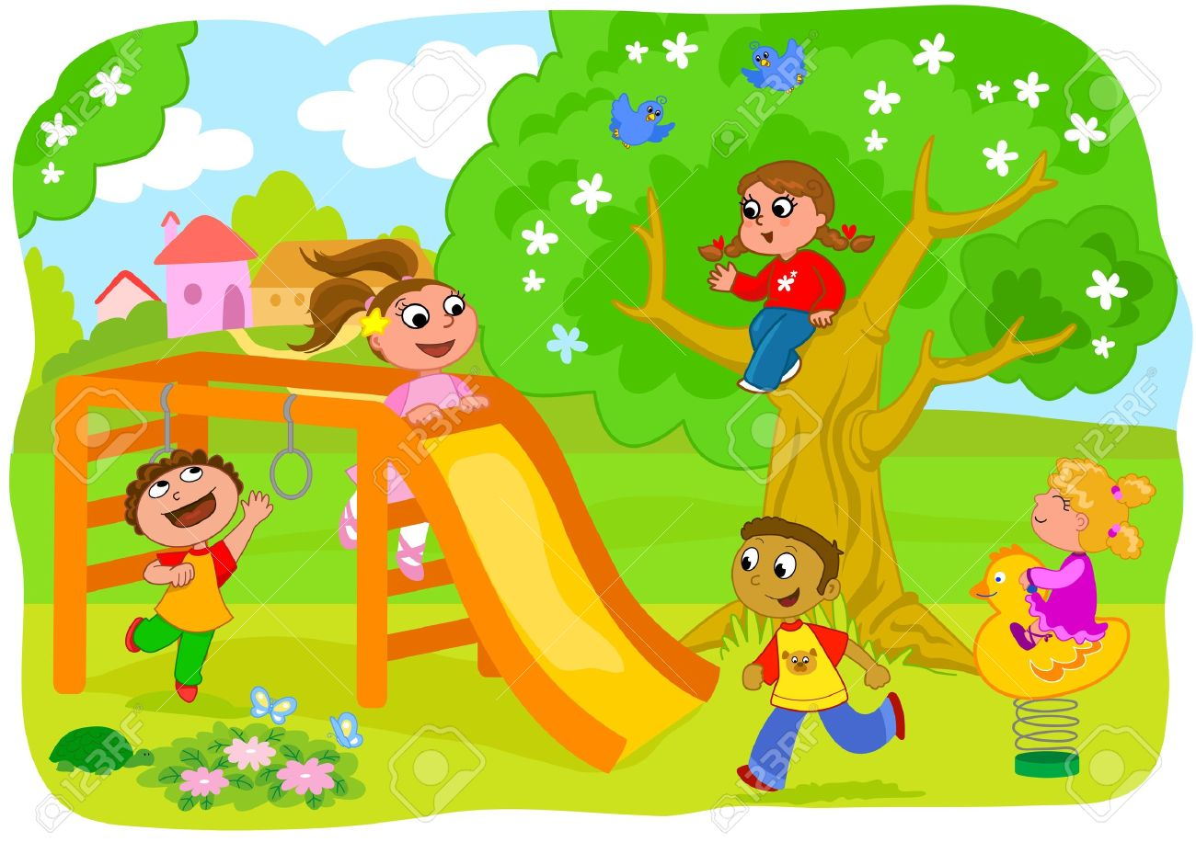

A
B
C
D
E
1

Question 2: Listen and write T ( True) or F ( False)



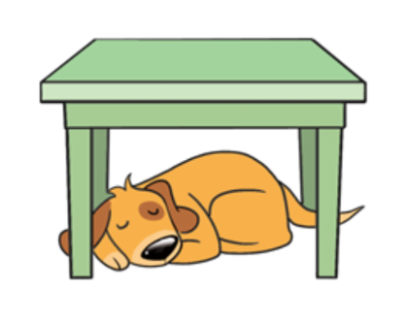
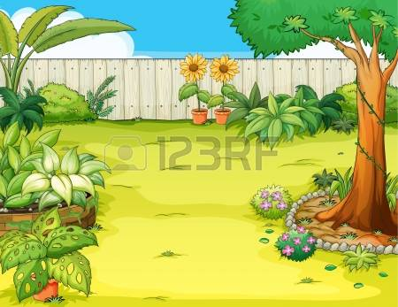
1. F
2…..
3…..
4…..
5…..



Question 3: Listen and draw the lines


1
2
3
4
5
A
B
C
D
E

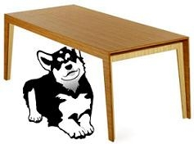
Question 4: Listen and tick ( ✓ )
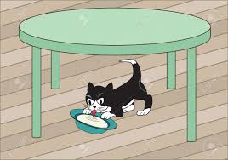
1.A

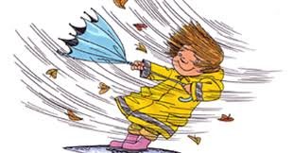





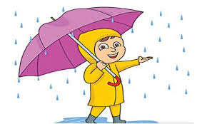
✓
B
2.A
B
3.A
B
4.A
B
B
5.A

B. Reading and writing

Question 5: Look and read. Put a tick (✓) or a cross ( X) in the box

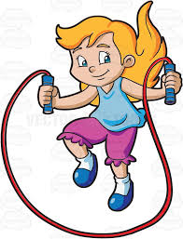

✓
1. The dog is under the table.
2. He likes planes.
3. She’s cooking.
4. How many windows are there?
There are two.
5.It’s cloudy today.

.

Question 6. Look at the pictures. Look at the letters. Write the words.
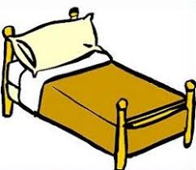




1.
2.
3.
5.
B O T O R ⇨ ROBOT
M O H T R E ⇨ ____________
A T C S ⇨ _______________
Y R A N I ⇨ ______________
E B D ⇨ _____________

4.

Question 7: Choose the right words to complete the sentences
reading
watching
cooking
reading
listening

1. I’m reading a book now.
2. My father is …………………to music.
3. My brother is ……………….. a comic book.
4. My mother is ………………. in the kitchen.
5. My sister is ………………. TV
Question 8: Read and match
1. How old are you?
2. How many dogs do you have?
?
3. Where’s Ha Noi?
4. What toys do you like?
5. Do you like toys?
A. I have three dogs.
B. I like yo-yos.

C. Yes, I do.

D. I’m ten.
E. It’s in North Vietnam.

